Oldtimer Rallye Tatry
2020
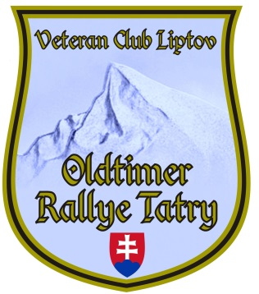

REGISTRATION

* Name and surname of the participant, title : ...........................................................

*Adress, PSČ : ...............................................................................................
*Phone : ............................................. *E-mail : ......................................

Name and surname of navigator, title: ..............................................................
on a special form
Adress, PSČ: ..........................................................................
Phone : ................................. E-mail : .........................................

* Historic car - manufacturer: ...................................
*Historic car – type : .................... * Year of production: .................. License historic car – number: .................................................. / optional /
License F.I.V.A. number: ........................................................... / optional /
Registration number / special CZ /: ................................................
Club : .................................. / optional /

I am ordering accommodation on a special form : ........................

By my signature, I agree to the processing of my personal data - solely to the extent of: name, surname, title, historical vehicle data, photo documentation and videos obtained during Oldtimer Rallye Tatra according to Act. no. 428/2002 Coll. on the protection of personal data, as amended.

In ................................................ Date: .................................

signature of the participant

Please send the application together with the photos as soon as possible to the e-mail address:
jaroslav@petran.sk, or by post to:
Jaroslav Petran, Námestie osloboditeľov 4, Liptovský Mikuláš, 031 01 Slovakia

Appendix:

P.S .: We would also like to welcome some interesting information about your vehicle or its
crew.

